OfficeOps TaxJar/NAV Integration
Contents
Overview 2
TaxJar Service Setup 3
Overview 3
Fields 3
Page Actions 4
NAV Objects 5
Table 5
Report 6
Codeunit 6
MenuSuite 6
Page 6

Overview
The TaxJar/NAV integration allows for the query of tax rates (based on ship-from/ship-to address information) from TaxJar in order to create the necessary tax records within NAV for any given sales transaction. The integration is real-time in that tax information will be queried once per day for a given ship-from/ship-to address as the information is populated on a Sales Order.
The tax integration can be used in one of two ways:
- Generic tax rates for any address regardless of nexus
- Nexus-specific tax information
Generic tax rates (if enabled) will be queried at the time the Ship-to Address information is entered on a NAV Sales Document but will not send any document information to TaxJar. Nexus-specific tax information (if enabled) will be queried as soon as financial information is entered on a NAV Sales Document (i.e. when Unit Price field is populated on a Sales Line that has a non-zero Quantity value).
To demonstrate generic tax rates only in NAV, the Enabled box should be checked and the Enable Document Processing unchecked. A user can then enter a Sales Order and observe the Tax Area Code auto-populate as soon as Ship-to information is entered/changed.
To demonstrate nexus-specific tax information, both the Enabled and Enable Document Processing checkboxes should be checked. A user can then enter a Sales Order and a Sales Line with a Quantity and Amount and observe the Tax Area Code auto-populate. If the Shipping Address information is changed, the user should be able to observe the Tax Area Code change as well.
The main area for the TaxJar/NAV integration can be found under the following menu: Departments/Financial Management/Setup/Administration/TaxJar Service Setup

TaxJar Service Setup
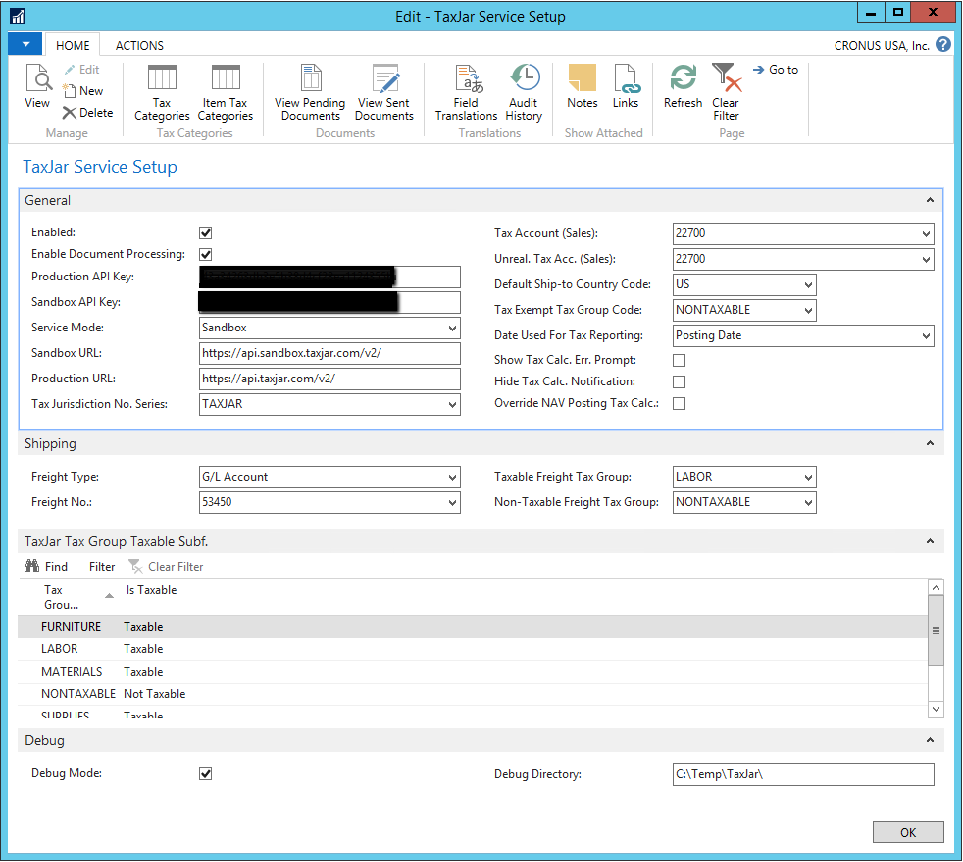

Overview
This page is the main interface in NAV for the TaxJar integration. The following fields and their uses are described below.

Fields
- Enabled: This field enables the TaxJar integration. If the Enabled Document Processing is not checked, then generic non-nexus tax rates will be utilized and no document-level tax information will be sent to TaxJar
- Enable Document Processing: This field will enable the nexus-specific tax integration to TaxJar and will also submit posted documents to TaxJar for tax reporting purposes (described below)
- Production API Key: The production API key provided from TaxJar to allow for the integration
- Sandbox API Key: The sandbox API key provided from TaxJar to allow for integration into the TaxJar sandbox environment. Please note that not all functionality is available within TaxJar’s sandbox environment (specifically, changing a Customer’s exemption status and collecting document information sent from NAV)
- Service Mode: Indicates if Sandbox or Production is in use
- Sandbox URL: The URL for the sandbox API endpoint
- Production URL: The URL for the production API endpoint
- Tax Jurisdiction No. Series: The NAV No. Series used to generate new Tax Jurisdiction records
- Tax Account (Sales): The G/L Account used in the tax records to record Sales Tax
- Unreal. Tax Acc. (Sales): The G/L Account used in the tax records to record unrealized Sales Tax
- Default Ship-to Country Code: If not Country Code is present on a given record in NAV, then this value will be used as it is required by TaxJar
- Tax Exempt Tax Group Code: The NAV Tax Group used for non-taxable records
- Date Used for Tax Reporting: The date used to record a transaction date when information is sent to TaxJar
- Show Tax Calc. Err. Prompt: In NAV 2017 and 2018, any TaxJar related errors will be shown as notifications on the page a user is on if an error occurs. Checking this box will cause a window to pop up with the error instead. The pop up can be more disruptive to a user, so this allows for flexibility in error reporting. In most cases, this box is unchecked
- Hide Tax Calc. Notification: Checking this box will suppress all TaxJar integration related errors. In most cases, this box is unchecked
- Override NAV Posting Tax Calc.: During sales document posting, NAV will recalculate tax. In some cases, this is not desirable. Checking this box will cause this native NAV functionality to be overridden and instead use the last tax information collected from TaxJar to record the tax information. In most cases, this box is unchecked
- Freight Type: The Type value on a Sales Line to indicate freight
- Freight No.: The No. value on a Sales Line to indicate freight
- Taxable Freight Tax Group: The NAV Tax Group Code to use on a Sales Line in the event that freight is taxable
- Non-Taxable Freight Tax Group: The NAV Tax Group Code to use on a Sales Line in the event that freight is not taxable
- TaxJar Tax Group Taxable Subf.: These fields should be used to list every Tax Group Code in NAV and its Taxable/Non-Taxable status
- Debug: This is primarily used for error reporting and will allow the specification of a folder for NAV to write all communication information to/from NAV to TaxJar

Page Actions
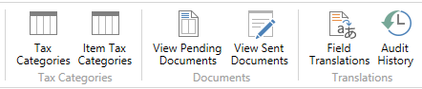
- Tax Categories: This will display a list of Tax Categories set up in TaxJar. The Download Tax Categories on this page will retrieve the latest list present in TaxJar. Tax Group Codes can then be mapped on this page to their relevant Tax Category. In most cases, TaxJar will automatically recognize a Customer’s tax exemption status and will handle this automatically, so this page is not typically used.
- Item Tax Categories: This page functions similarly to the NAV Sales Prices page in that particular Customers, Customer Groups, etc., their related Ship-to Codes, etc., and Item/Item Categories, etc., can be mapped to indicate that a particular Tax Category should be used. In most cases, TaxJar will automatically recognize a Customer’s tax exemption status and will handle this automatically, so this page is not typically used
- View Pending Documents: This page shows all documents that are pending submission to TaxJar. In most cases, this page is reviewed prior to closing a monthly accounting period, and the Submit Document Queue action is used to send the document-level (nexus-specific) tax information to TaxJar. The Queue Posted Documents action can be used to enter historical data if any back records need to be sent. This page is editable for corrections in the event that any errors are indicated from TaxJar after submitting the documents
- View Sent Documents: This page shows all documents that have been successfully sent to TaxJar
- Field Translations: This page will auto-populate with default values and is used to indicate how certain fields should be handled. For example, TaxJar only accepts two character Country Codes – thus, if a NAV implementation uses USA, this table will indicate that USA needs to translate to US when communicating with TaxJar. Additionally, if any states, countries, etc., should not be sent to TaxJar, then the Ignore for TaxJar box can be checked for the relevant values
- Audit History: This page will show a list of all communication sent to TaxJar. This can be used to reconcile TaxJar fees

NAV Objects
The following NAV objects are affected by the TaxJar integration

Table
- 18 Customer
  - Field added: TaxJar Exemption Type
- 36 Sales Header
  - Field added: TaxJar Update
  - Field added: Freight Taxable
  - Field added: Tax Calculation Valid
  - Field added: Tax Calculation Message Type
  - Field added: Tax Calculation Message
  - Field added: Ignore for TaxJar (note: this field can be programmatically used to suppress certain documents from interacting with the TaxJar integration)
  - Field added: Ship-to County Name
  - Field added: Sell-to County Name
- 37 Sales Line
  - Field added: TaxJar Tax Rate
  - Field added: TaxJar Tax Amount
- 112 Sales Invoice Header
  - Field added: Freight Taxable
  - Field added: Ship-to County Name
- 113 Sales Invoice Line
  - Field added: TaxJar Tax Rate
  - Field added: TaxJar Tax Amount
  - Field added: TaxJar Order No.
  - Field added: TaxJar Order Line No.
- 114 Sales Cr.Memo Header
  - Field added: Freight Taxable
  - Field added: Ship-to County Name
- 115 Sales Cr.Memo Line
  - Field added: TaxJar Tax Rate
  - Field added: TaxJar Tax Amount
- 73000 TaxJar Service Setup
- 73001 TaxJar Tax Group Taxable
- 73002 TaxJar Field Translation
- 73003 TaxJar Jurisdiction Mapping
- 73004 TaxJar Document Queue
- 73005 TaxJar Document Entry
- 73006 TaxJar Tax Category
- 73007 TaxJar Item Tax Category
- 73008 TaxJar Document Line Breakdown
- 73009 TaxJar Error Message
- 73010 TaxJar API Audit History

Report
- 73000 TaxJar Submit Document Queue
- 73001 TaxJar Queue Posted Documents

Codeunit
- 73000 TaxJar Communication
- 73001 TaxJar Utilities
- 73002 TaxJar NAV API Interface
- 73003 TaxJar Tax Calculation
- 73004 TaxJar Document Management
- 73005 TaxJar Document API
- 73006 TaxJar Tax Category Management
- 73007 TaxJar Error Message Mgt.
- 73008 TaxJar Customer API

MenuSuite
- 1059 TaxJar MenuSuite

Page
- 21 Customer Card
  - Added field: TaxJar Exemption Type
- 46 Sales Order Subform
  - Added field: TaxJar Tax Rate
  - Added field: TaxJar Tax Amount
- 47 Sales Invoice Subform
  - Added field: TaxJar Tax Rate
  - Added field: TaxJar Tax Amount
- 96 Sales Cr.Memo Subform
  - Added field: TaxJar Tax Rate
  - Added field: TaxJar Tax Amount
- 113 Posted Sales Invoice Subform
  - Added field: TaxJar Tax Rate
  - Added field: TaxJar Tax Amount
- 135 Posted Sales Cr. Memo Subform
  - Added field: TaxJar Tax Rate
  - Added field: TaxJar Tax Amount
- 73000 TaxJar Service Setup
- 73001 TaxJar Tax Group Taxable Subf.
- 73002 TaxJar Document Queue List
- 73003 TaxJar Document Entries
- 73004 TaxJar Tax Categories
- 73005 TaxJar Item Tax Categories
- 73006 TaxJar Tax Amount Breakdown
- 73007 TaxJar Field Translations
- 73008 TaxJar API Audit History

