taxjar for dynamics NAV

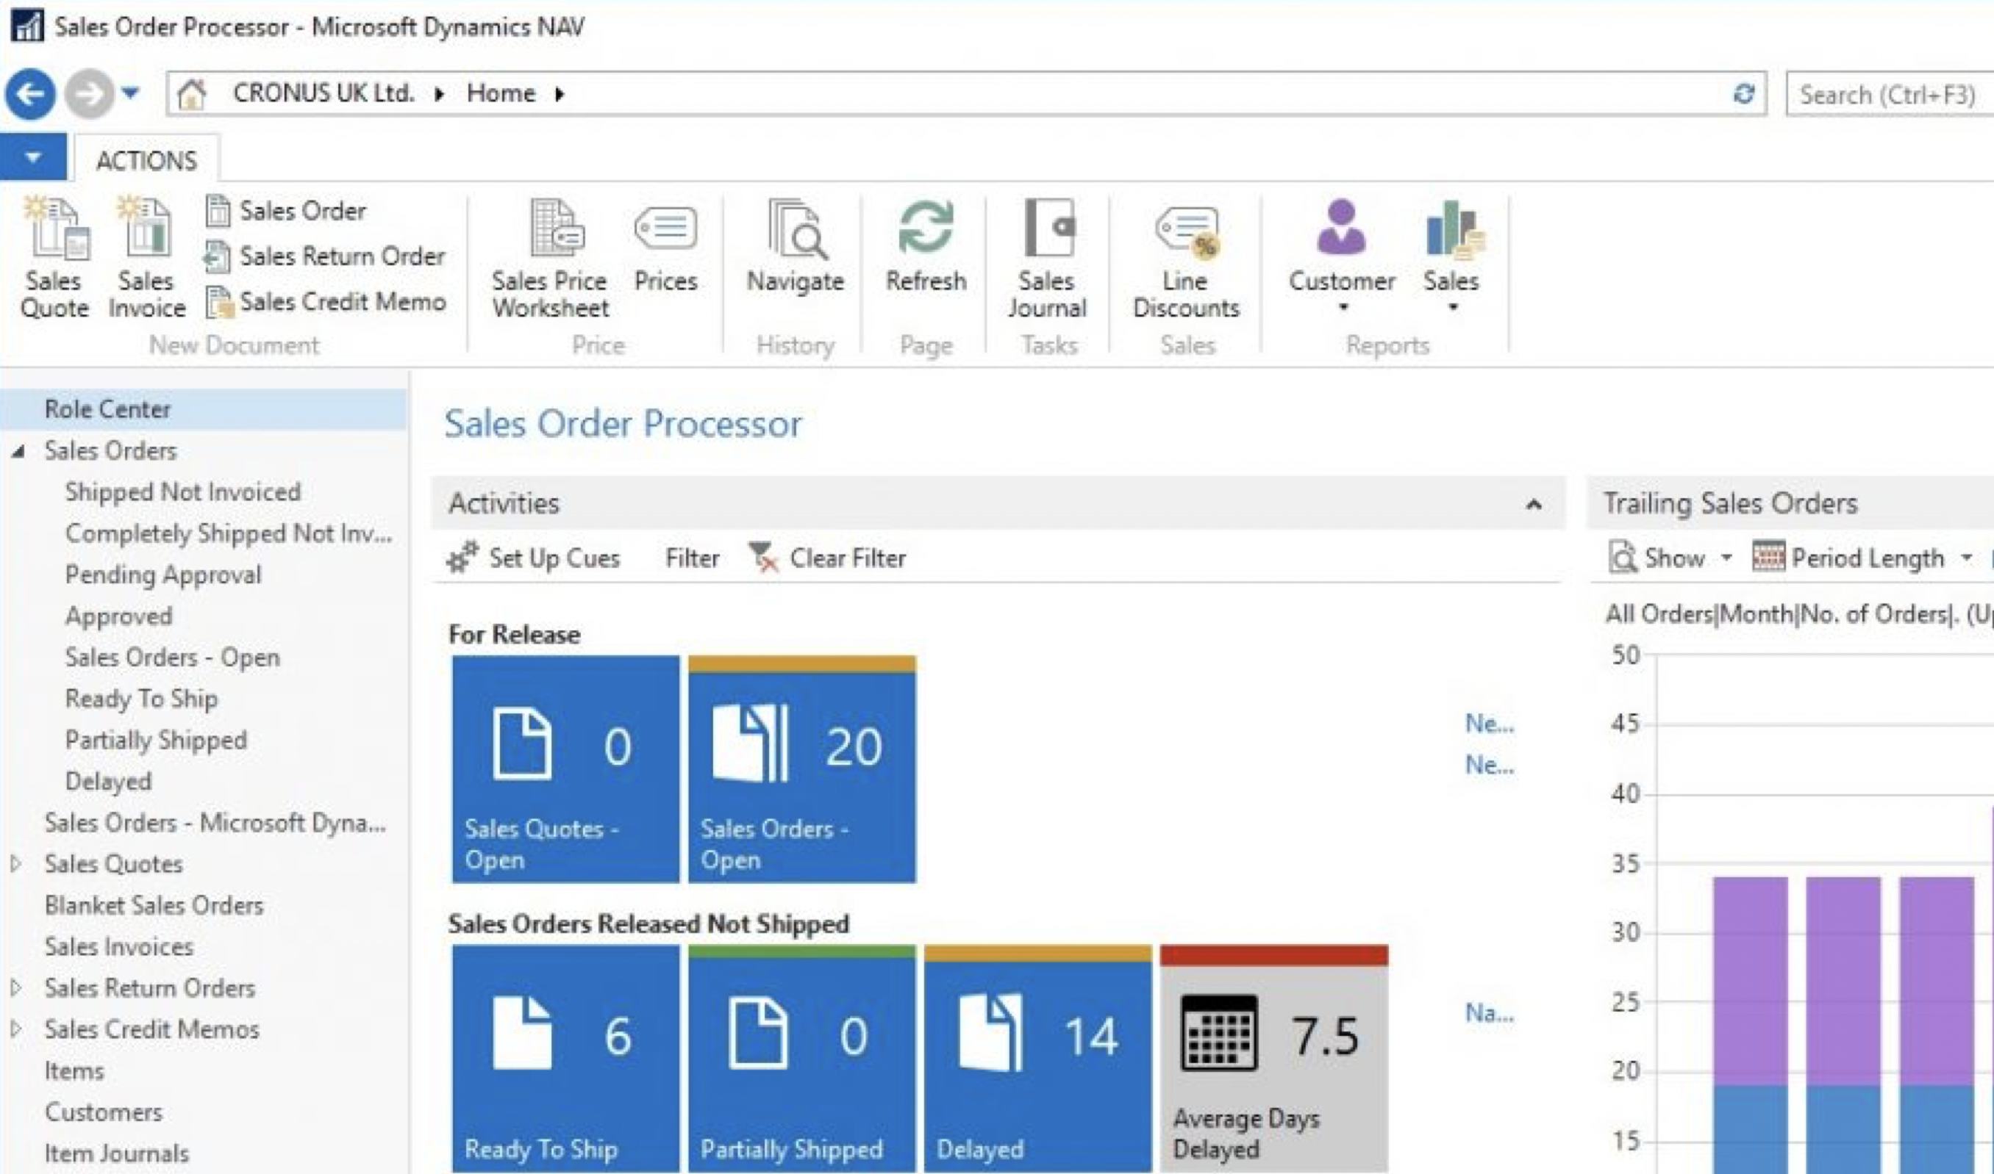
Simplify your sales tax compliance with TaxJar and Dynamics NAV

Our TaxJar for NAV connector guarantees you seamless integration to your ERP. The connector automates your tax calculations, reporting and filings.

How it works
The TaxJar for Dynamics NAV connector allows you to query tax rates (based on ship-from/ship-to address information) from TaxJar in order to create the necessary tax records within NAV for any given sales transaction. The integration is real-time, tax information will be queried once per day for a given ship-from/ship-to address as the information is populated on a Sales Order.

©2019 TaxJar. TaxJar is a trademark of TPS Unlimited.

